Please search for ‘putty’ from the Search window. This will be available by default in all SCE devices.



Double click on ‘PUTTY.EXE’. The below window will open. Enter the IP address (or) host name of the server that is intended. Port should always be maintained as **‘22’**

Hostname IPv4

ayxcdgrm03 172.28.48.131

ayxcdgrm01 172.28.48.132

ayxcdgrm02 172.28.48.133

ayxcdgrm04 172.28.48.130

ayxcdgrm05 172.28.48.135

ayxcdgrm06 172.28.48.134

ayxcdgrm07 172.28.48.136

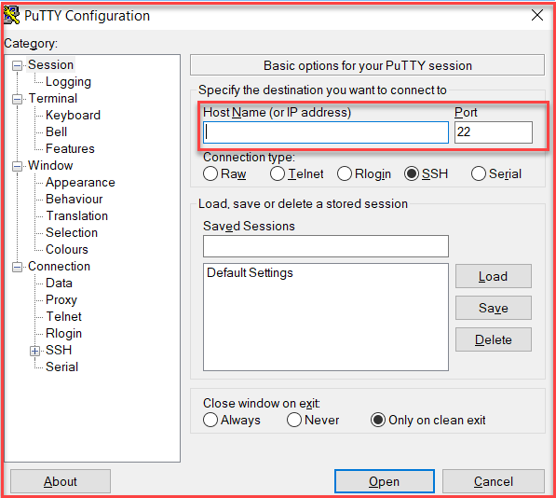

Below window would pop-up asking for login ID and password. Please enter your SCE ID (login ID for your device) and its password. User should be able to login in to the server.

